The TB6560 and Arduino
Filed under: Acquiring Parts, Code, Electronics, Motors — 4 Comments
January 19, 2012
So, I’ve recently acquired from eBay a few TB6560 stepper motor controllers. After working with the L298n which is nothing more than an H-Bridge, I wanted to try and work with an actual stepper motor controller and the specs, with 3A per phase along with being a through hole components (along with the cheap price and eBay availability) made me get some.
The first problem: the HZIP25 package of the IC doesn’t really fit in a breadboard.. . How can you work with that? Make a breakout board of course! I’ve found the schematics for one online (which I can’t find again), but that one required me to make my own PCBs, which is a place I’m not ready to go to yet.
The solution was to make one on my own, based on a regular, simple one sided protoboard. I’ve soldered two lines of female headers, and then used wires to connect them to male headers on the other side. this way I can remove/replace the IC if anything happens or if I want it for another circuit. Although it has some of my worst soldering ever, it still works here it is:
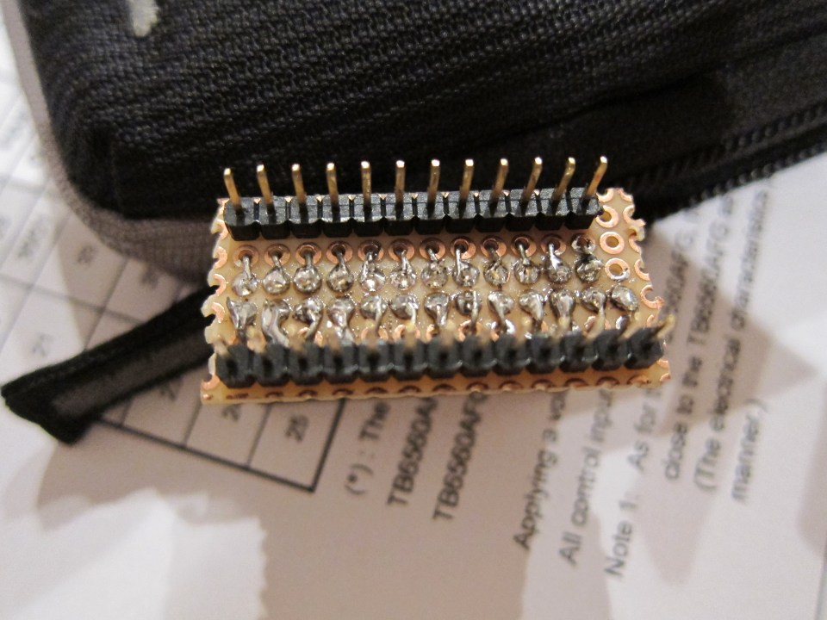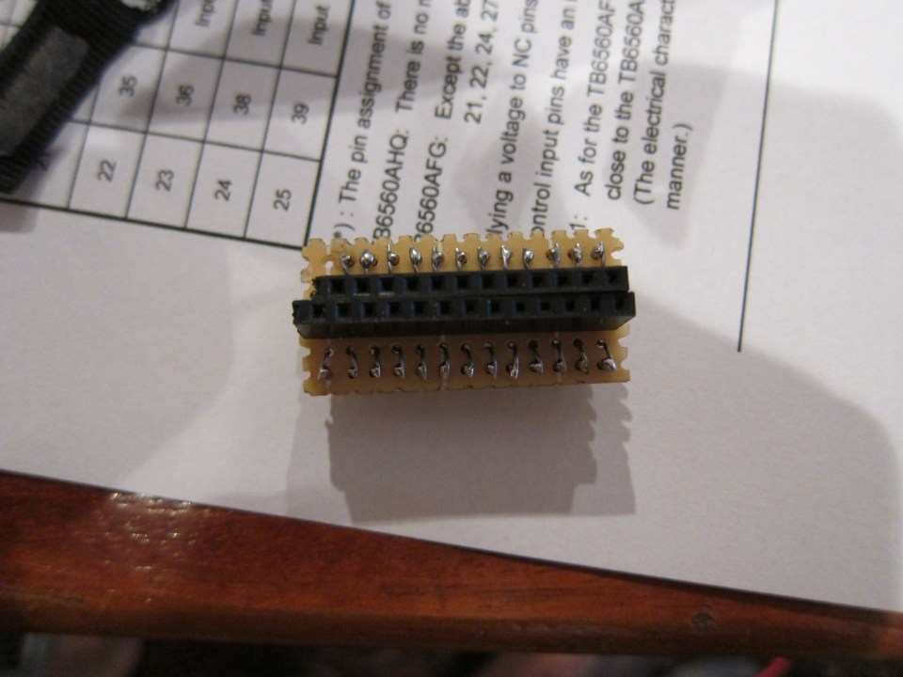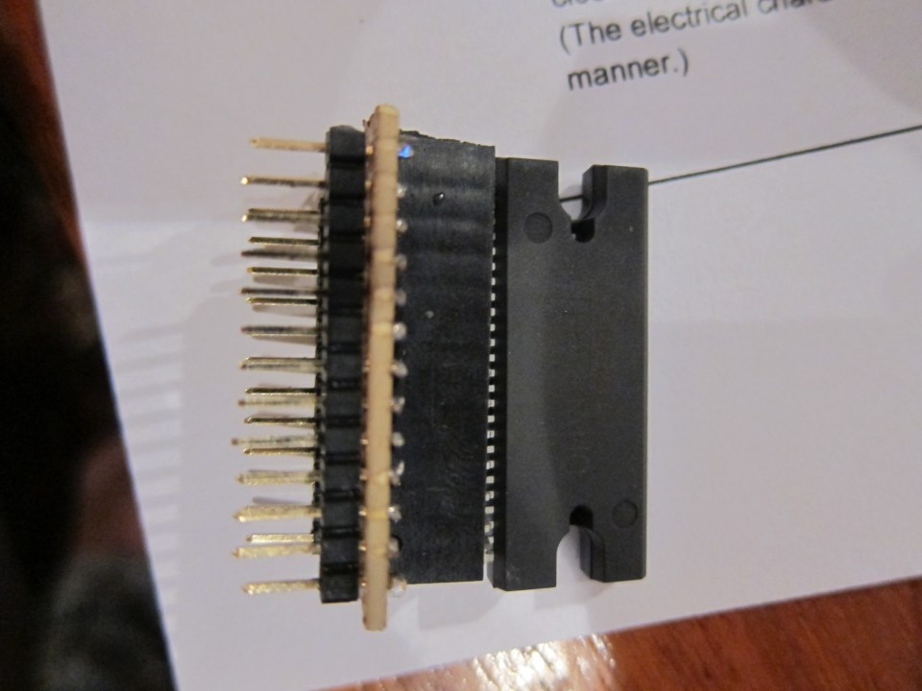
Next up: Wiring on the breadboard! Unfortunatly I didn’t document the process, but this is how it ended up like:
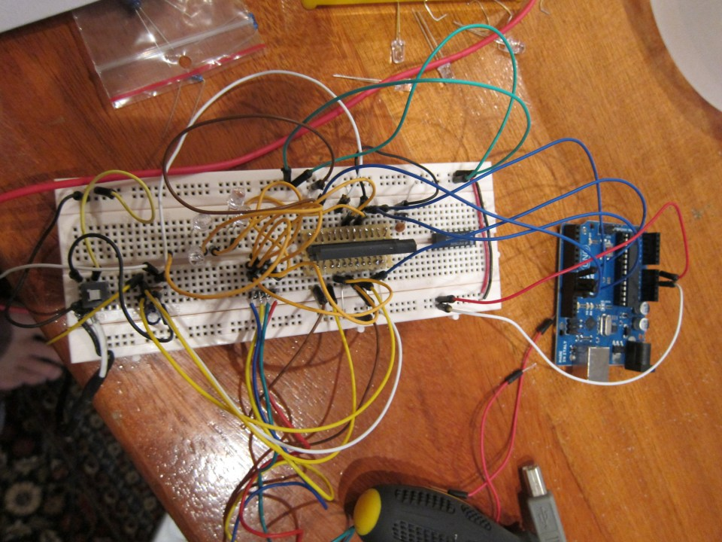
To do it I followed the datasheet, which is pretty straight forward. I connected the CLK, ENABLE, RESET and CW/CCW to the Arduino. All of the configuration pins (M1, M2, DCY1, DCY2, TQ1, TQ2) were connected to ground, although you can just leave them not connected as they are all pulled down (meaning they are connected to ground inside the IC).
As it comes to power – initially I’ve tried connecting all of the power inputs to the same power rail with 5V, and connected 4 LEDs (don’t forget resistors) to see the polarity in both phases. After I tried to connect a motor it seemed like the power wasn’t sufficient so I moved to my lab power supply with 15V. I’ve initially thought I can seperate the GNDs, as it seemed rational when looking at the layouts and datasheet, but performance was much better with common ground.Don’t forget capacitors, and checking their specs. I blew up a 16V capacitor trying to see how the motor copes with 24V of power.
Other pins:
- OSC was connected to a 1000pf capacitor (one side connected to the pin, the other to GND). read the datasheet, I used this one because I had it laying around, I would rather use a 100pf one if available.
- Nfa, Nfb: As my motors don’t even come near to their specs I just connected it directly to ground. If you want to use them to limit the current then: resistor value (in Ohms) = 1 / (2 * Max current (in amps))
- M0, Protect: After looking at this circuit, I just left them disconnected. will probably use the M0 later when writing a library for this controller
Next up: coding.
Initially I’ve tried to go all crazy and try and write a library before anything even started working in prototype mode. This is of course known as the sin of Hubris, so naturally it all failed (miserably). Back to prototyping mode! I went to the Toshiba site, where turns out they have an Application Notes document, It has info on both the circuit you have to build and the start up sequence, As it turns out my intuition failed on the order of setting the RESET and ENABLE pins to high. have a look there, even if you’re just using my code.
So here is the code I’ve got so far to run the motor switching directions every 10 turns (at full step, less in microstepping mode):

#define CLK_PIN 9
#define ENABLE_PIN 8
#define RESET_PIN 10
#define CCW_PIN 11
void setup() {
// Make all the pins OUTPUT and set them to LOW
for (int i = 8 ; i <= 11 ; i++) {
pinMode(i, OUTPUT);
digitalWrite(i, LOW);
}
// This is the order according to the application notes
digitalWrite(RESET_PIN, HIGH);
digitalWrite(ENABLE_PIN, HIGH);
}
int del = 750;
int counter = 0;
int dir = LOW;
void loop() {
// Send out a clock signal. switch the direction bit every 2000 clocks.
digitalWrite(CLK_PIN, HIGH);
delayMicroseconds(del);
digitalWrite(CLK_PIN, LOW);
delayMicroseconds(del);
counter++;
if (counter == 2000) {
if (dir == LOW) {
dir = HIGH;
}
else {
dir = LOW;
}
digitalWrite(CCW_PIN, dir);
counter = 0;
}
}
<pre>// Define pins;
#define CLK_PIN 9
#define ENABLE_PIN 8
#define RESET_PIN 10
#define CCW_PIN 11
void setup() {
// Make all the pins OUTPUT and set them to LOW
for (int i = 8 ; i <= 11 ; i++) {
pinMode(i, OUTPUT);
digitalWrite(i, LOW);
}
// This is the order according to the application notes
digitalWrite(RESET_PIN, HIGH);
digitalWrite(ENABLE_PIN, HIGH);
}
int del = 750;
int counter = 0;
int dir = LOW;
void loop() {
// Send out a clock signal. switch the direction bit every 2000 clocks.
digitalWrite(CLK_PIN, HIGH);
delayMicroseconds(del);
digitalWrite(CLK_PIN, LOW);
delayMicroseconds(del);
counter++;
if (counter == 2000) {
if (dir == LOW) {
dir = HIGH;
}
else {
dir = LOW;
}
digitalWrite(CCW_PIN, dir);
counter = 0;
}
}

Next up: Add a shift register to control the configuration pins, I think including ENABLE and RESET, don’t have to change those very often. (and of course M1,2, DCY1,2, and TC1,2). This way I can control a TB6560 with 5 pins, and N controllers with 2N + 3 pins. Start using the M0 to change the configuration when best. Probably not needed for the actual project, but might be better when prototyping.
I think I’ll build a playground board for this – Control all of the settings via switches/buttons. Even control the delay time with a potentiometer.
On a side note: I’ve built the frame for the prototype pong, and I gt the pulleys I’ve had made. Once this thing ends I’ll start working on the “Ball” mechanism, hopefully I’ll have some cool videos
Edit: After moving the project to the Lab I’ve tried to make it work again and failed. turns out that when using low resistance stepper motors at high voltage (let’s say 20V) than the controller just crashes due to noise on the GND channel. I solved it by separating the grounds. Took me lots of time to figure out. I really need an Oscilloscope

